Skip Lists

Brief Introduction

* Skip list is a simple, efficient and randomized dynamic search structure. Which has a running time of O(logn) in expectation with high probability.
* It is a multilevel ordered linked list, where only certain elements are promoted to higher levels based on certain probability condition.
* Searching begins at highest level, to quickly get to the nearest element, then progressively uses lower level lists.
* Skip list has its application in Express and local subway lines in à la New York City 7th Avenue Line (representation is shown below).

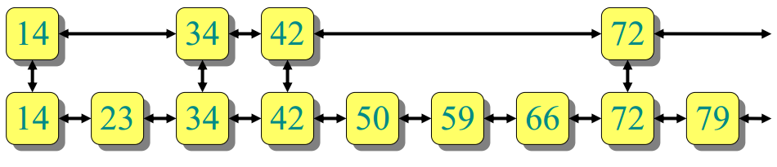

Analysis of skip list search.

* Let number of links in top list be l1 and bottom list be l2.
* Search cost is = $\left|l_{1}\right|+ \frac{\left|l_{2}\right|}{\left|l_{1}\right|}$ and is Minimized (up to constant factors) when terms are equal.
* Therefore the least number of nodes $l_{1}$ must have is $\sqrt{l_{2}}$ thus for every $\sqrt{n} th$ node a second level skip list node is preferred, resulting in a search cost of $2\sqrt{n}$.
* Similarly it can be deduced that 3 sorted lists result in search cost of $3\sqrt[3]{n}$. And lg n sorted lists costs 2 lg n. Figure below is an ideal skip list.

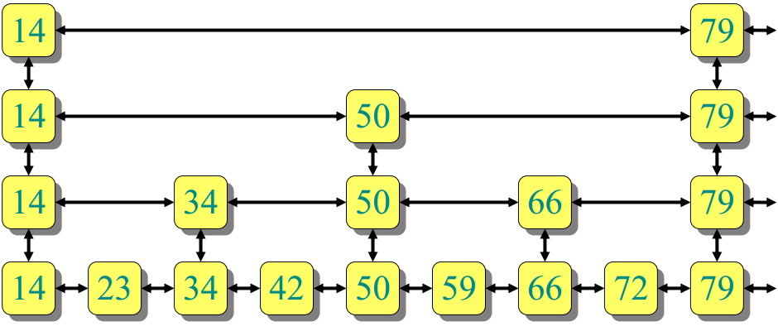

Analysis of Insert

* The question to which other levels should a value be added is can be related to a flip of coin.
* Probability of promotion to next level = 1/2
* On average:

1/2 of the elements promoted 0 levels.

1/4 of the elements promoted 1 level.

1/8 of the elements promoted 2 levels.